How has skin color impacted the Kettering/Dayton area in modern times?
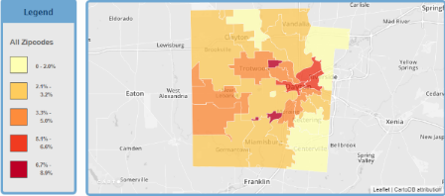
Poverty Table
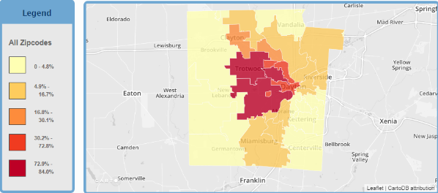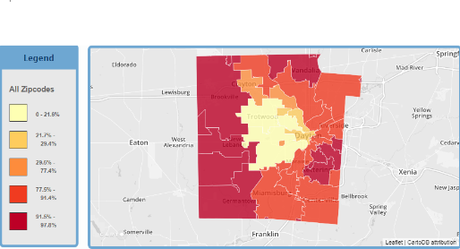
Black Population Table White Population Table
Sources
- "Unintentional Drug Overdose Death Rate, 2011-2013",,
Data Source: Ohio Department of Health, Bureau of Vital Statistics,,
- Poverty Status: Percent of families below the poverty level, 2008-2012,"
Data Source: US Census Bueau, 2008-2012 American Community Survey,,

According to the graph the more people in poverty the more overdose deaths there are. In the scatter plot, you can see poverty on the bottom and overdose deaths on the left side. In the maps under that, it shows population rates by area, and poverty rates by area. In the scatter plot, there is lines that go upward meaning that overdose deaths rise as poverty rates fall. In the tables under that you can see maps for the most common races and poverty rates in Montgomery County.

